**Assignment Cover**

Assignment Details: Prepare a budget sheet by MS Word

Project Name: Shipping Budget Details

Course: Smart Office Management

Batch No: SO(07)

Trainee Name: MD SABBIR AHMED SOPAN

Trainee ID: 11

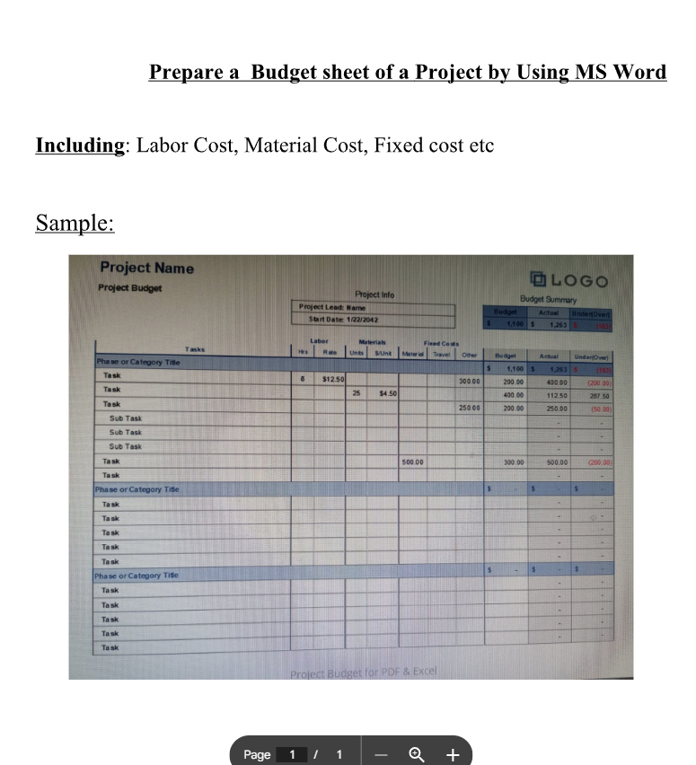

* This is cover of assignment